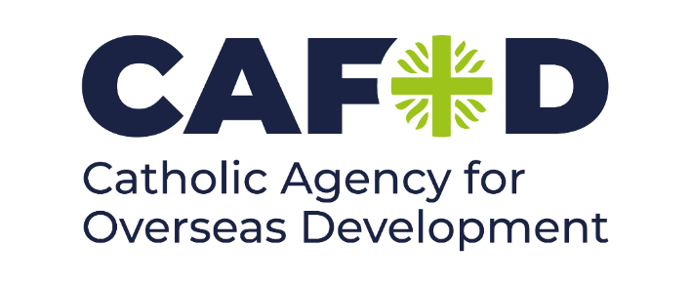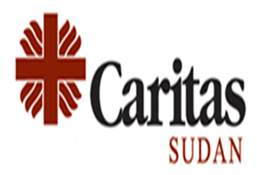

Date: 16/05/2024

TENDER ADVERTISEMENT
SUPPLYING OF 3195 HH HYGIENE & DIGNITY KITS IN WHITE NILE STATE

Catholic Agency for overseas Development (CAFOD) with funds from Caritas International and in partnership with CARITAS SUDAN are implementing a WASH project in White Nile State host community & IDPs. The project is targeted to support the improvement of hygiene and sanitation needs of the host community & IDPs. CAFOD and Caritas Sudan are seeking tenders from qualified vendors / suppliers/ for supplying 3,195 HH Hygiene & Dignity kits in White Nile State.

CAFOD and CARITAS SUDAN invite all interested suppliers/vendors/contractors to collect tender documents from CAFOD offices KOSTI between 16 May 2024 to 26 May 2024.
note: A letter delegating an individual from the company is required when receiving the tender Dossier.

Tender documents can be collected from 19 May 2024 during working days and hours (11.00am to 3:00 pm)
Interested vendors/suppliers/ contractors MUST provide the following information indicating that they are qualified to the works:
- The company’s valid registration or trade License
- Taxation chamber & Zakat certifications and other government related registration
- History / profile of the company
- Description of similar assignments achieved.
- Evidence of experience in similar works
- Financial ability \current bank statement (this will be kept as confidential document)
- Guarantee cheque from the bank ((this will be kept as confidential document) - letter from Insurance Company
- Delivery time
The last date for submission of completed sealed bids is 26 May 2024 by 3:00 pm, incomplete bids will not be considered.
For more information, please contact the following.
CAFOD Office in Kosti, Rabak Street, El Andalus Area, South to El Andalus School
Phone Numbers for More Information: 0912164425 tagahmed@cafod.org.u

